Preguntas Objetivo 3

Pregunta 1
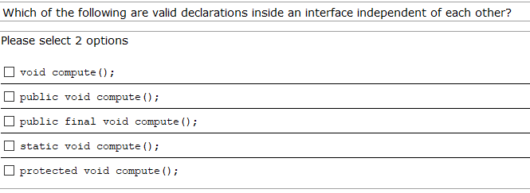
a,b
d No, porque hay ;
final no puede ser, porque no es la función de la interfaz.

Pregunta 2
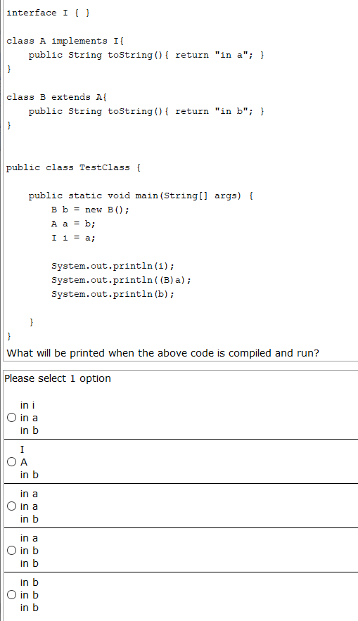

e

Pregunta 3
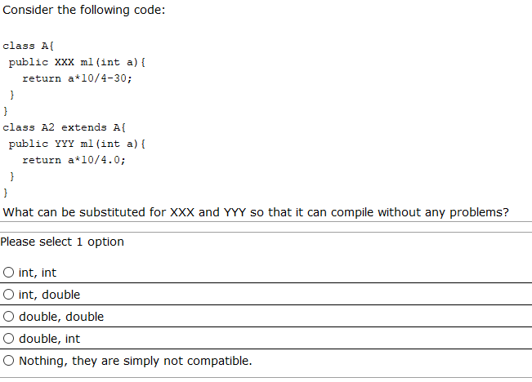
* double, double.
Porque como A2 devuelve un double, la clase A no puede ser menor o más restrictivo.

Pregunta 4
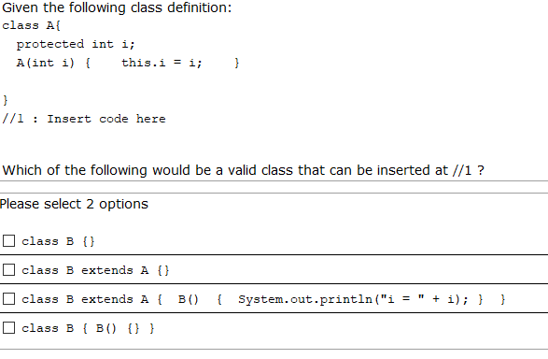

1 bien
2 Error, como B tiene constructor por defecto, llamaría al constructor por defecto de A, que no lo hay.
3 Igual que la anterior.
4 bien.

Pregunta 5
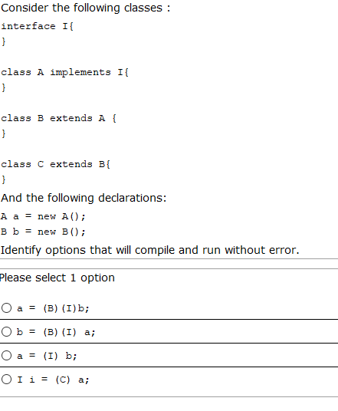
d) No, porque a no es un C.
c) No, porque A = I, no se pude asignar un I directamente a A.
b) No, en el primer paso, tipo I pero objeto es A, no se puede convertir ese objeto A en B (que es el segundo casteo).

Pregunta 6
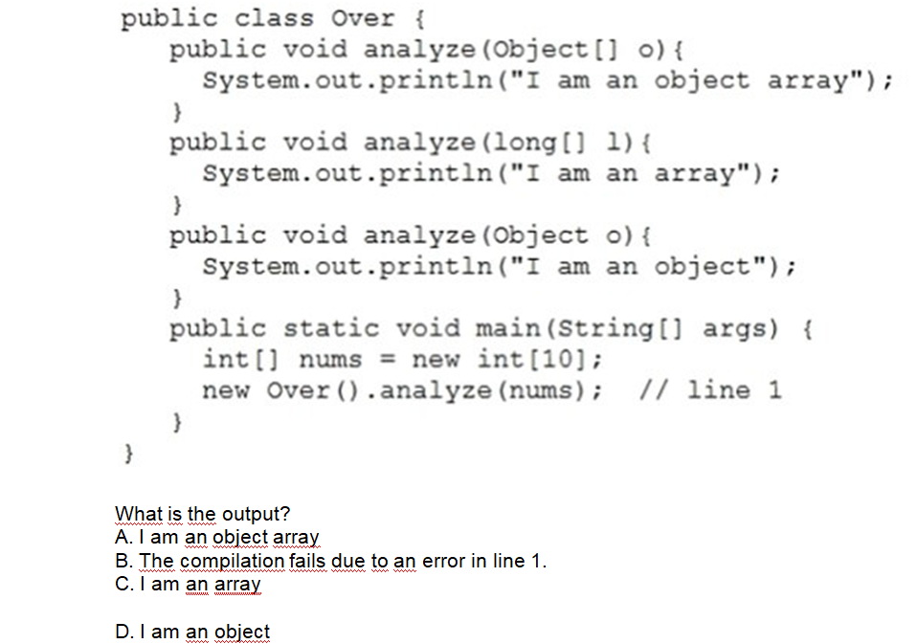
D. (No habría promoción de tipos de long) Porque un array de un tipo, no se puede convertir a un array de otro tipo, porque son objetos.

Pregunta 7
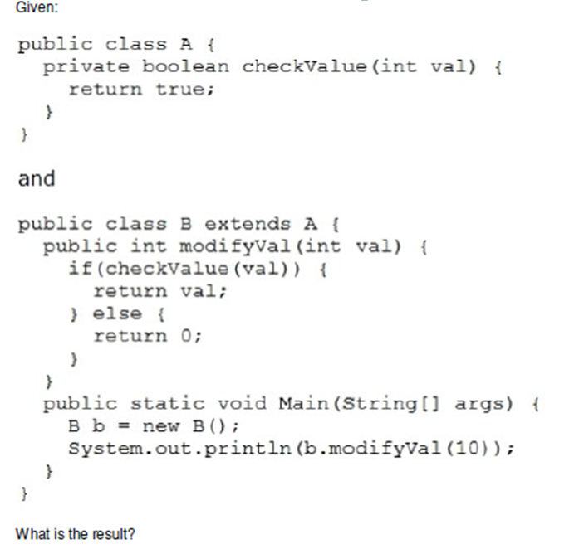
A. nothing
B. It fails to compile.
C. 0
D. A java.lang.IllegalArgumentException is thrown.
E. 10

Pregunta 8
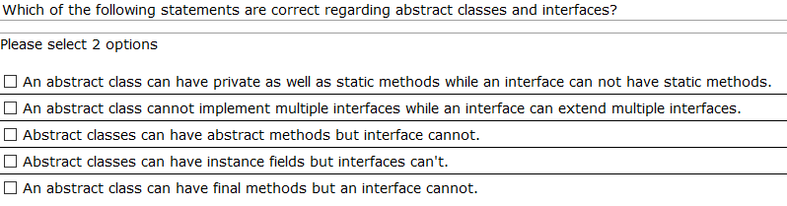

Pregunta 9
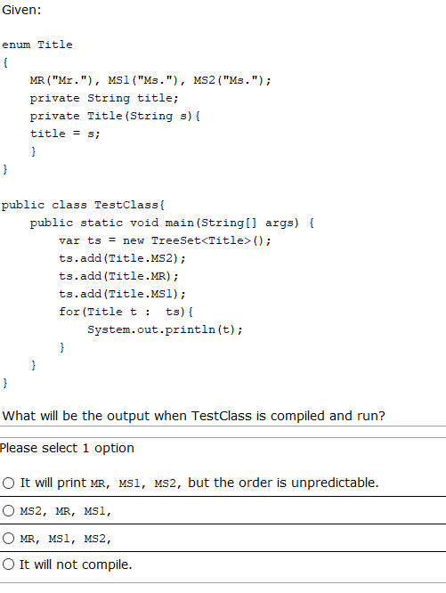

Pregunta 10
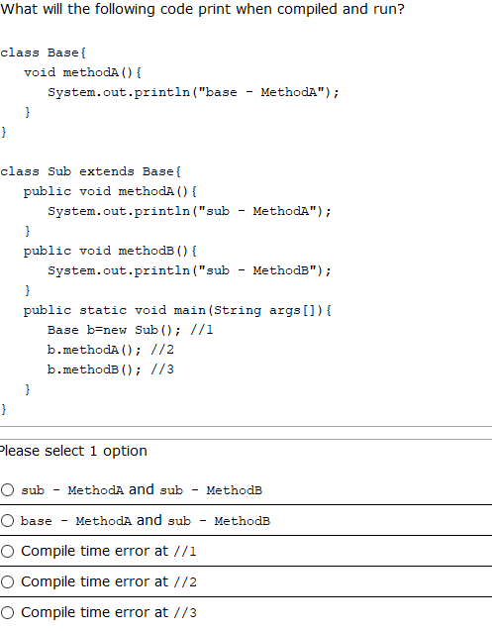

Pregunta 11
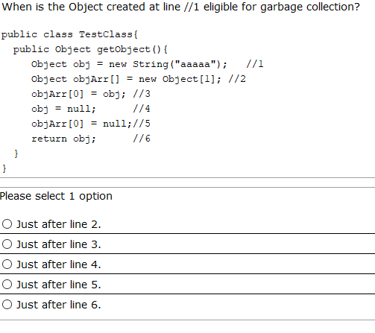

Pregunta 12
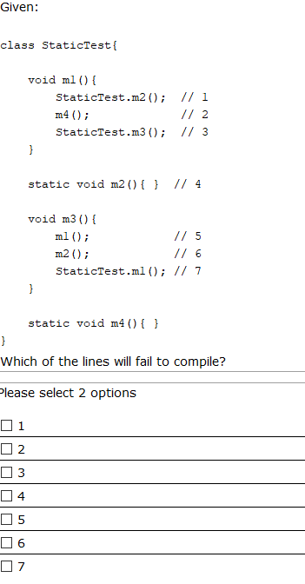

Pregunta 13
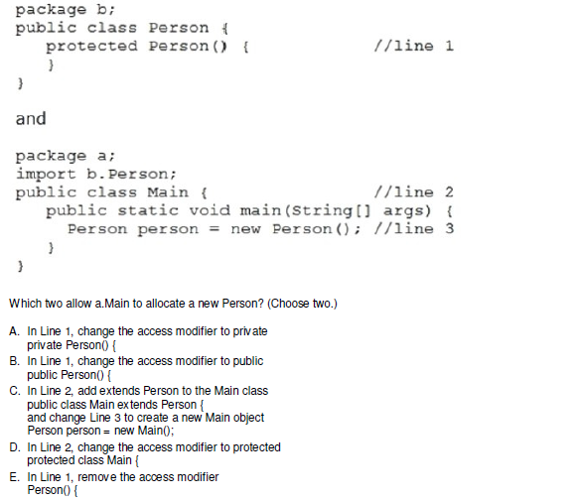

Pregunta 14
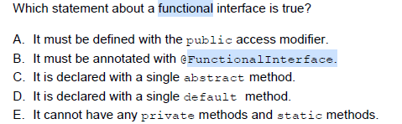

C

Pregunta 15

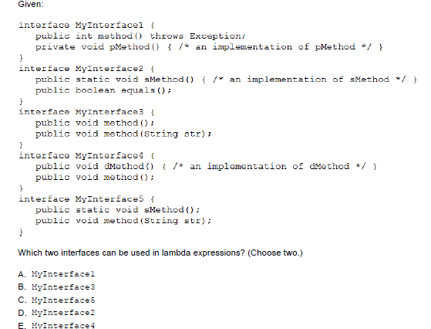
a,d
La segunda, sí, porque ese método de equals no está sobreescribiendo el de object. Porque el de object recibe un objeto.

Pregunta 16
Given the following
class Test{
int a;
static int b;
static{
b++;
}
Test(){
while(a<5){
b++;
a++;
}
}
public static void main(String[] args){
Test t1=new Test();
Test t2=new Test();
System.out.println(t1.a+":"+t2.b);
}
}
Which is the result?
A. 10:10
B. 5:10
C. 5:11
D. 11:5
E. Compilation fails

Pregunta 17
Given:
C1.java
package p1;
public class C1{
int p; // default sólo ámbito de paquete.
private int k;
public int s;
protected int x;
}
C2.java
package p2;
import p1.C1;
public class C2 extends C1{
public static void main(String[] args){
C1 obj=new C1();
}
}
Which statement is true?
- Both p and s are accesible by obj
- p, s and x are accesible by obj
- Only s is accesible by obj //
- Only x is accesible by obj
- Both x and s are accesible by obj
- C. None of the variables are accesible by obj
x=10; // ok
p = 2; // No
obj.x; // No, porque no se puede acceder fuera del contexto de la herencia.

Pregunta 18
Given the following:
public class Test {
public Test(){
System.out.println("No params");
}
public void Test(int j){
System.out.println("Param "+j);
}
public static void main(String[] args) {
Test t=new Test(3);
}
}
Which is the result?
A. Param 3
B. No params
C. Compilation fails
D. Exception

Pregunta 19

Consider the following code:
class MyClass { }
public class TestClass{
MyClass getMyClassObject(){
MyClass mc = new MyClass(); //1
return mc; //2
}
public static void main(String[] args){
TestClass tc = new TestClass(); //3
MyClass x = tc.getMyClassObject(); //4
System.out.println("got myclass object"); //5
x = new MyClass(); //6
System.out.println("done"); //7
}
}

After what line the MyClass object created at line 1 will be eligible for garbage collection?
A. 2
B. 5
C. 6
D. 7
E. Never until the program ends

Pregunta 20
What will be the contents of s1 and s2 when the control reaches the println statement in the main method of the following program?
import java.util.*;
public class TestClass{
public static void main(String args[]){
Stack s1 = new Stack ();
Stack s2 = new Stack ();
processStacks (s1, s2);
System.out.println (s1 + " "+ s2);
}
public static void processStacks(Stack x1, Stack x2){
x1.push (new Integer ("100"));
//assume that the method push adds the passed object to the stack.
x2 = x1;
}
}

A. [100][100]
B. [100][]
C. [][100]
D. [][]

Pregunta 21
Given the following pairs of method declarations, which of the statements are true? (choose 2)
1.
void perform_work(int time){ }
int perform_work(int time, int speed){ return time*speed ;}

2.
void perform_work(int time){ }
int perform_work(int speed){return speed ;}

3.
void perform_work(int time){ }
void Perform_work(int time){ }

A. The first pair of methods will compile without errors and they correctly demonstrate method overloading
B. The second pair of methods will compile correctly and overload the method 'perform_work'
* La devolución es indiferente. No sería correcta. no compila.
C. The third pair of methods will compile correctly and overload the method 'perform_work'
D. The second pair of methods will not compile correctly
E. The third pair of methods will not compile correctly

Pregunta 22
Given:
class Base{
public List<CharSequence> transform(Set<CharSequence> list){
//valid code
};
}
class Derived extends Base{
*INSERT CODE HERE*
//valid code
}
}
What can be inserted in the above code?
A. public List<String> transform(Set<String> list){
B. public List<Object> transform(Set<CharSequence> list){
C. public ArrayList<CharSequence> transform(Set<CharSequence> list){
D. public List<StringBuilder> transform(Set<CharSequence> id){
E. public List<Integer> transform(TreeSet<CharSequence> id){
F. public ArrayList<String> transform(Set<String> id){

Pregunta 23

Consider the following classes...
class Teacher{
void teach(String student){
/* lots of code */
}
}
class Prof extends Teacher{
//1
}
Which of the following methods can be inserted at line //1 ?
A. public void teach() throws Exception
B. private void teach(int i) throws Exception
C. protected void teach(String s)
D. public final void teach(String s)
E. public abstract void teach(String s) // No al no ser la clase abstracta, aunque sí puede definirse abstracto un método que se hereda.

